Project 1

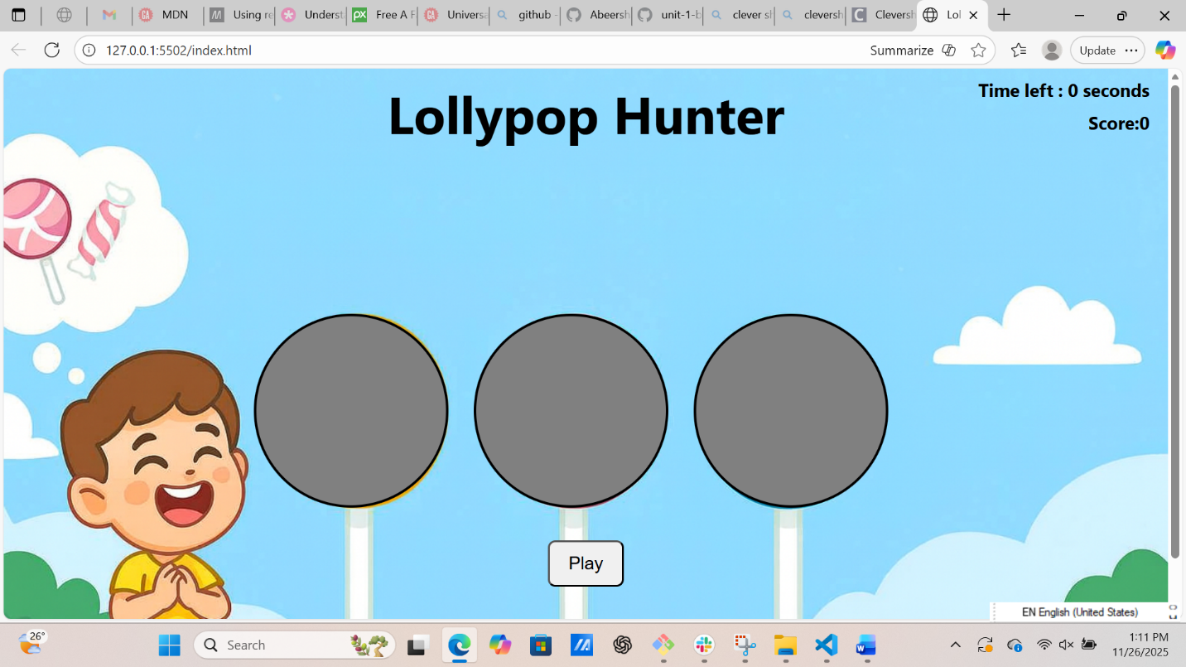
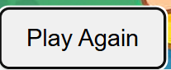
Screenshot/Logo :

Your game's name:
Lollypop Hunter Game .
As you a player you must help this kid to collect 3 or more lollypops to win the game , if you collect less than 3 lollypops then you will lose.
If you want to play again you must click the Play Again button to restart the game.
I choose this game because I can use the basic fundamentals and then I can go more advanced .
Getting started:
The game’s link : https://abeersharif111.github.io/Lollypop-Game/

Attributions:
- For generating the background I used : copilot.
- For the sounds I used : https://pixabay.com .
Technologies used:
- JavaScript.
- HTML.
- CSS .

Next steps:
Planned future enhancements :
- At the beginning of the game there will be a basket that positioned at the ground in the right side of the lollypops , as much as he click red lollypops the basket will be moved to left side near to the kid .
- If the basket reach the kid then it will be great so the kid will dance .
- If he clicked a blue lollypop, the basket will move back to the right far a step of the kid and the score will decreased by 1 and I want a message indicating that I have a fault.
- If he clicked the black lollypop the basket will return back to its original location and the score becomes to 0 .

